PT 8637
TIME CLOCK INTERFACE

The PT 8637 Time Clock Interface can be installed in the PT 5230 Digital Video Generator.

Packing list:
Check that the PT 8637 option package contains the following items:
 | Description: | Item | Quantity
 | Cable clamp | 2508 700 00001 | 4
 | Pan Head Screw M3x6 | 2522 178 31058 | 8
 | Pan Head Screw M3x8 | 2522 178 31059 | 4
 | Curved Spring washer | 2522 728 04003 | 2
 | Ribbon Cable with micro 20P | 4008 105 04030 | 1
 | Cable Assy with female XLR | 4008 105 04030 | 1
 | Distance Piece M3 | 4008 107 36490 | 6
 | Time clock Interface Assy | 4008 109 84830 | 1

The system is “plug and play” meaning that when the unit is mounted no configuration is needed in order to enable the PT 8637.

Installation procedure:
- Open the PT 5230 by removing the top cover.
- Remove the 6 screws on the main board in the front left part, and mount the 6 spacers instead.
- Place the PCB board on the spacers and fasten the board with the screws (Fig. 1).
- Mount the ribbon cable from the PT 8637 printed circuit board to the PT 5230 main board .
- Mount the cable assembly with the XLR connector on the rearplate, fixing the connector with 2 screws (M3x6).
- Mount the other end of the cable in the PT 8637 option.

- The cable is secured along the right side of the chassis by means of the cable clamps and the M3x8 screws.
- If not PT 8635 installed: Three clamps and screws are mounted on the integral spacers in the chassis.
- PT 8535 mounted: Remove 3 screws along the side of the board and fix the cable by means of cable clamps and the M3x8 screws.
- Fix the cable to center of the Sync Generator board (close to the oven).
- Mount the top cover on the PT 5230.
- Turn on power, and observe that the menu includes the Time Clock Interface unit.
- Place the option type plate on the side of the generator in order to make later identification possible

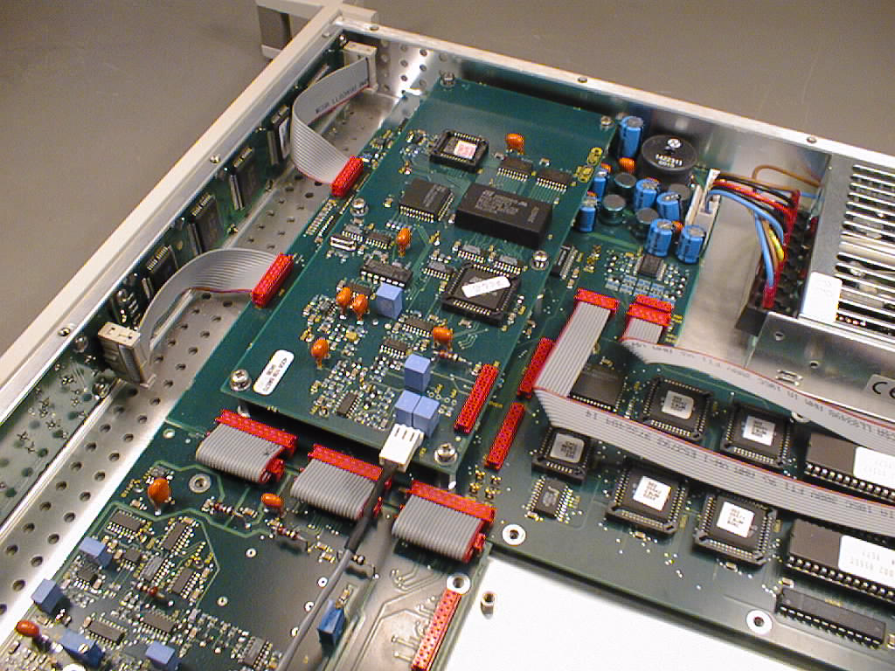
Mount Ribbon cable between these 2 connectors
Cable to rearplate

Picture 1. The installed PT 8637 Time Clock Interface
NOTE, before the ribbon cable is installed

